##### **A PROJECT REPORT**

**On**

**Resume Builder**

###### **Submitted by**

**Student name:** **Student ID No.:**

##### 1.Debanjan Barua 22IUT0010200

2.Surajit Shil 22IUT0010229

3.Soubam Yaipha 22IUT0010231

4.Anish Deb 22IUT0010232

5.Sourav Das 22IUT0010250

6.Tapash Saha 22IUT0010251

***In partial fulfillment for the award of the degree***

***of***

**B.Tech**

*Under the Guidance of*

**Guide Name:Prof. Rajib Chowdhury**

**Designation:Assistant Professor**



The ICFAI University, Tripura

DEPARTMENT OF COMPUTER SCIENCE AND ENGINEERING

**Faculty of Science and Technology**

**Course Code:SIP-I**

**Course Title: Summer Internship Program – I**

**May 2023**

**INDEX**

**Contents**  **Page no**

Declaration I

Certificate II

Acknowledgement III

Abstract IV

Introduction V

Objective VI

Scope VII

System analysis VIII

Flowchart IX

Coding X

Testing and Evaluation XI

Conclusion XII

References XIII



**The ICFAI University, Tripura**

**DEPARTMENT OF COMPUTER SCIENCE AND ENGINEERING**

**Declaration of Student**

We hereby declare that the project entitled “**Resume Builder** ” submitted for the B.Tech(CSE) degree is my original work and the project has not formed the basis for the award of any other degree, diploma, fellowship or any other similar titles.

| **SL No** | **Name** | **Roll No** | **Signature** |
| --- | --- | --- | --- |
| 1 | Debanjan Barua | 22IUT0010200 |  |
| 2 | Surajit Shil | 22IUT0010229 |  |
| 3 | Soubam Yaipha | 22IUT0010231 |  |
| 4 | Anish Deb | 22IUT0010232 |  |
| 5 | Sourav Das | 22IUT0010250 |  |
| 6 | Tapash Saha | 22IUT0010251 |  |

|  |  |
| --- | --- |



**The ICFAI University, Tripura**

**DEPARTMENT OF COMPUTER SCIENCE AND ENGINEERING**

**CERTIFICATE**

This is to certify that the project titled “_Resume_Builder ” is the bona fide work carried out by Debanjan Barua, Surajit Shil , Soubam Yaipha , Anish Deb , Sourav Das , Tapash Saha , a student of B.Tech(CSE) of Department of Computer Science and Engineering, The ICFAI University, Tripura during the academic year ...2023.., in partial fulfillment of the requirements for the award of the degree of B Tech (CSE) and that the project has not formed the basis for the award previously of any other degree, diploma, fellowship or any other similar title.

**Signature : …………………………**

**Name of Faculty Guide:** **Rajib Chowdhuri**

**Designation:** **Assistant Professor**

**Signature: …………………………**

**Name: Dr. Saptarshi Chakraborty**

**HOD, CSE**

**Signature : …………………………**

**Name: Dr. Prasanta Kumar Sinha**

**Principal,ICFAI Technical School**

# ACKNOWLEDGEMENT

We extend heartfelt gratitude to everyone who contributed to the success of our project, "**Resume Builder**". Special thanks to our project supervisor **Prof. Rajib Chowdhuri** , for their invaluable guidance and support throughout. The faculty members of **CSE** **Department ,ICFAI UNIVERSITY TRIPURA** deserve appreciation for providing essential resources and an enriching academic environment, which facilitated our project's execution. We are also thankful to our peers and classmates for their valuable input and engaging discussions, helping us refine our ideas and approach.

We express deep gratitude to our respected **HOD Dr. Saptarshi Chakraborty** and **Principal Dr. Prasanta Kumar Sinha** for providing crucial data and tools that significantly enriched our project. Without their contribution, our project would not have achieved the same level of completeness and success. We also want to acknowledge the unwavering encouragement and understanding of our friends and family, whose support kept us motivated during challenging phases, making this journey possible.

Last but not least, we recognize and appreciate the collaborative efforts of each team member. Their dedication, cooperation, and diverse skills complemented one another, resulting in a cohesive and successful outcome for "Resume Builder." We acknowledge the contribution of anyone else who may have been inadvertently omitted from this acknowledgement but played a role in our project's realization. Thank you all for being an integral part of our journey in creating the "**Resume Builder**" project.

# ABSTRACT

Our resume builder website “Squaddesk” is a user-friendly and intuitive platform designed to empower job seekers in creating professional resumes effortlessly. Developed using HTML, CSS, and JavaScript, this application offers a streamlined resume building process without the need for a login page or database integration, ensuring a hassle-free experience for users.

With our website, users can showcase their skills, experiences, and accomplishments using customizable templates that suit various industries and job roles. The intuitive user interface enables easy drag-and-drop functionality, allowing users to arrange resume sections effortlessly.

The website offers a wide range of formatting options, font styles, and color schemes to match individual preferences. Users can also preview their resumes in real-time before generating the final PDF version.

By eliminating the complexities of database integration and login procedures, our resume builder aims to provide a seamless and efficient solution for job seekers to create stunning resumes, highlighting their strengths and increasing their chances of landing their dream job.

**Chapter 1: Introduction**

* 1. **Problem Definition**

A resume is like a written summary of a person's work history, skills, education, and accomplishments. It's like a personal advertisement that job seekers use to show potential employers why they would be a good fit for a job. Resumes typically include information such as your contact details, work experience, education, and any special abilities or achievements you want to highlight. The main goal of a resume is to impress employers and convince them to invite you for an interview to learn more about you and your qualifications.

The problem our resume builder website aims to address is the challenge faced by job seekers in creating effective and professional resumes. Crafting a compelling resume that showcases one's skills, experiences, and achievements can be a daunting task, especially for individuals from diverse backgrounds and career stages. Many job seekers struggle to format their resumes attractively and often lack access to expert guidance in tailoring their content for specific job opportunities. Our website aims to simplify the resume-building process and provide users with user-friendly tools, customizable templates, and valuable tips to help them create standout resumes that catch the attention of potential employers. By addressing these resume-related challenges, our platform seeks to empower job seekers and increase their chances of securing their desired job roles.

**1.2 Project Overview/Specifications**

The **Resume Builder** website named “**Squaddesk**” is an innovative online platform designed to revolutionize the way job seekers create and present their resumes. The primary goal of this project is to offer users a seamless and user-friendly experience in crafting compelling and professional resumes that cater to their unique skills and experiences. The website will be accessible from various devices, ensuring users can conveniently build and edit their resumes from anywhere.

Key Specifications:

1. User-Friendly Interface: The website will feature an intuitive and user-friendly interface that allows users to effortlessly navigate through the resume-building process. The layout will be simple, with clear instructions to guide users in entering their information and customizing their resumes.
2. Resume Editor: The website will incorporate a powerful resume editor, enabling users to input, modify, and format their content in real-time. The editor will support various formatting options, ensuring visually appealing and well-structured resumes.
3. Expert Tips and Guidance: To aid users in crafting effective resumes, the website will provide expert tips and guidance throughout the resume-building process. These insights will help users optimize their content, highlight their key achievements, and align their resumes with specific job requirements.
4. Data Security: Ensuring data privacy and security is paramount. The website will implement robust security measures to protect user information, assuring users that their personal and professional details are safe.
5. Mobile Responsiveness: The website will be fully responsive to different screen sizes, ensuring a seamless experience on desktops, laptops, tablets, and smartphones.

**1.3 Hardware & Software Requirements**

**Hardware Requirements:**

1.PC with Windows 7/8/10/11 with at least 4 GB Ram(8 GB recommended) and 256 GB of storage.

2.Stable Internet connection.

**Software Requirements:**

**1.VS Code Editor**: This is the main software to write your HTML, CSS, and JavaScript code. It's a free and popular code editor that you can download from the official website.

**2.Web Browser:** A web browser like Google Chrome, Mozilla Firefox, or Microsoft Edge to test and preview your resume builder.

**3.Github:** Github to host the website using github pages functionality.

**Chapter 2: Literature Survey**

* 1. **Existing System**

In the existing system, the available resume builder websites, such as Resume.com, Canva, and Novoresume, have certain shortcomings. Firstly, they often require registration and sign-up, making the resume-building process lengthy and complicated for users. Secondly, a majority of these platforms are not free, requiring users to pay for access to premium templates and features. Lastly, data privacy and security concerns have been raised as many of these existing systems may lack adequate measures to safeguard users' personal information and ensure data confidentiality. These drawbacks highlight the necessity for an improved and user-centric resume builder website like "Squaddesk," which addresses these issues and offers a more seamless and secure experience for job seekers.

* 1. **Proposed System**

The proposed system, "**Squaddesk**," aims to revolutionize the resume-building experience with a comprehensive and user-centric platform. It will offer an intuitive interface with an extensive library of customizable templates, catering to various industries and career levels. The powerful resume editor will enable real-time content editing and formatting, ensuring visually appealing and professional resumes. Expert tips and guidance throughout the process will optimize content and highlight achievements. Emphasizing data security, "Squaddesk" will implement robust measures, including encrypted data transmission and secure storage. The feasibility study indicates that "Squaddesk" is technically and financially viable, meeting the demand for a user-friendly resume builder website.

* 1. **Feasibility Study**

The feasibility study concludes that the development of "Squaddesk" is both technically and financially feasible. There is a significant demand for a comprehensive and user-friendly resume builder platform, making it a promising venture in the market. The required hardware and software resources are readily available and accessible. The financial analysis demonstrates reasonable development and maintenance costs, justifying potential returns from user subscriptions and premium features. Considering the increasing demand for tailored resumes and the potential for success, "Squaddesk" holds strong feasibility and is poised to meet the needs of job seekers effectively.

**Chapter 3:System Analysis and Design**

**3.1 Flowchart**

**HOME**

**PRINT RESUME**

**RESUME FORM FILLUP**

**RESUME BUILDER**

**CREATE RESUME**

**3.2 Design and Testing**

**Design**

**1.Landing Page:**

Clean and modern design with a professional color scheme.

Minimalist layout to create a focused and uncluttered appearance.

Clear and prominent headline indicating it's a "Resume Builder."

Engaging hero image or illustration showcasing a person at work or in a professional setting.

**2.Create New Resume:**

Step-by-step wizard-style design to guide users through the resume creation process.

Option to choose from different resume templates with thumbnail previews.

Intuitive and user-friendly interface for entering personal details, education, work experience, skills, and other relevant sections.

**3.Resume Sections:**

Distinct and visually appealing sections for personal information, work experience, education, skills, projects, certifications, and more.

Utilization of icons or graphics to represent each section, making it visually appealing and easy to navigate.

**4.Responsive Design:**

Ensuring the website is fully responsive and looks great on various devices (desktops, tablets, smartphones).

Mobile-friendly navigation and layout to provide a seamless experience on smaller screens.

**Testing**

**Functional Testing:**

Tested the website's functionality to ensure that all features and components work as intended.

Verified links, buttons, forms, navigation, and interactive elements.

**Compatibility Testing:**

Tested the website on various web browsers (e.g., Chrome, Firefox, Safari, Edge) and devices (desktop, tablet, mobile) to ensure consistent performance across different platforms.

**Security Testing:**

Checked for vulnerabilities and potential security risks and found the website to be safe.

**3.3 Coding**

**Resume Section:**

<!DOCTYPE html>

<html>

<head>

<meta charset="utf-8">

<meta http-equiv="X-UA-Compatible" content="IE=edge">

<title>Resume Page</title>

<meta name="description" content="">

<meta name="viewport" content="width=device-width, initial-scale=1">

<!-- custom css -->

<link rel="stylesheet" href="docs/css/main.css">

</head>

<body>

<nav class = "navbar bg-white">

<div class="container">

<div class = "navbar-content">

<div class = "brand-and-toggler">

<a href = "inner_index.html" class = "navbar-brand">

<img src = "docs/images/curriculum-vitae.png" alt = "" class = "navbar-brand-icon">

<span class = "navbar-brand-text">build <span>resume.</span>

</a>

<button type = "button" class = "navbar-toggler-btn">

<div class = "bars">

<div class = "bar"></div>

<div class = "bar"></div>

<div class = "bar"></div>

</div>

</button>

</div>

</div>

</div>

</nav>

<section id = "about-sc" class = "">

<div class = "container">

<div class = "about-cnt">

<form action="" class="cv-form" id = "cv-form">

<div class = "cv-form-blk">

<div class = "cv-form-row-title">

<h3>about section</h3>

</div>

<div class = "cv-form-row cv-form-row-about">

<div class = "cols-3">

<div class = "form-elem">

<label for = "" class = "form-label">First Name</label>

<input name = "firstname" type = "text" class = "form-control firstname" id = "" onkeyup="generateCV()" placeholder="e.g. John">

<span class="form-text"></span>

</div>

<div class = "form-elem">

<label for = "" class = "form-label">Middle Name <span class = "opt-text">(optional)</span></label>

<input name = "middlename" type = "text" class = "form-control middlename" id = "" onkeyup="generateCV()" placeholder="e.g. Herbert">

<span class="form-text"></span>

</div>

<div class = "form-elem">

<label for = "" class = "form-label">Last Name</label>

<input name = "lastname" type = "text" class = "form-control lastname" id = "" onkeyup="generateCV()" placeholder="e.g. Doe">

<span class="form-text"></span>

</div>

</div>

<div class="cols-3">

<div class = "form-elem">

<label for = "" class = "form-label">Your Image</label>

<input name = "image" type = "file" class = "form-control image" id = "" accept = "image/*" onchange="previewImage()">

</div>

<div class = "form-elem">

<label for = "" class = "form-label">Designation</label>

<input name = "designation" type = "text" class = "form-control designation" id = "" onkeyup="generateCV()" placeholder="e.g. Sr.Accountants">

<span class="form-text"></span>

</div>

<div class = "form-elem">

<label for = "" class = "form-label">Address</label>

<input name = "address" type = "text" class = "form-control address" id = "" onkeyup="generateCV()" placeholder="e.g. Lake Street-23">

<span class="form-text"></span>

</div>

</div>

<div class = "cols-3">

<div class = "form-elem">

<label for = "" class = "form-label">Email</label>

<input name = "email" type = "text" class = "form-control email" id = "" onkeyup="generateCV()" placeholder="e.g. johndoe@gmail.com">

<span class="form-text"></span>

</div>

<div class = "form-elem">

<label for = "" class = "form-label">Phone No:</label>

<input name = "phoneno" type = "text" class = "form-control phoneno" id = "" onkeyup="generateCV()" placeholder="e.g. 456-768-798, 567.654.002">

<span class="form-text"></span>

</div>

<div class = "form-elem">

<label for = "" class = "form-label">Summary</label>

<input name = "summary" type = "text" class = "form-control summary" id = "" onkeyup="generateCV()" placeholder="e.g. Doe">

<span class="form-text"></span>

</div>

</div>

</div>

</div>

<div class="cv-form-blk">

<div class = "cv-form-row-title">

<h3>achievements</h3>

</div>

<div class = "row-separator repeater">

<div class = "repeater" data-repeater-list = "group-a">

<div data-repeater-item>

<div class = "cv-form-row cv-form-row-achievement">

<div class = "cols-2">

<div class = "form-elem">

<label for = "" class = "form-label">Title</label>

<input name = "achieve_title" type = "text" class = "form-control achieve_title" id = "" onkeyup="generateCV()" placeholder="e.g. johndoe@gmail.com">

<span class="form-text"></span>

</div>

<div class = "form-elem">

<label for = "" class = "form-label">Description</label>

<input name = "achieve_description" type = "text" class = "form-control achieve_description" id = "" onkeyup="generateCV()" placeholder="e.g. johndoe@gmail.com">

<span class="form-text"></span>

</div>

</div>

<button data-repeater-delete type = "button" class = "repeater-remove-btn">-</button>

</div>

</div>

</div>

<button type = "button" data-repeater-create value = "Add" class = "repeater-add-btn">+</button>

</div>

</div>

<div class="cv-form-blk">

<div class = "cv-form-row-title">

<h3>experience</h3>

</div>

<div class = "row-separator repeater">

<div class = "repeater" data-repeater-list = "group-b">

<div data-repeater-item>

<div class = "cv-form-row cv-form-row-experience">

<div class = "cols-3">

<div class = "form-elem">

<label for = "" class = "form-label">Title</label>

<input name = "exp_title" type = "text" class = "form-control exp_title" id = "" onkeyup="generateCV()">

<span class="form-text"></span>

</div>

<div class = "form-elem">

<label for = "" class = "form-label">Company / Organization</label>

<input name = "exp_organization" type = "text" class = "form-control exp_organization" id = "" onkeyup="generateCV()">

<span class="form-text"></span>

</div>

<div class = "form-elem">

<label for = "" class = "form-label">Location</label>

<input name = "exp_location" type = "text" class = "form-control exp_location" id = "" onkeyup="generateCV()">

<span class="form-text"></span>

</div>

</div>

<div class = "cols-3">

<div class = "form-elem">

<label for = "" class = "form-label">Start Date</label>

<input name = "exp_start_date" type = "date" class = "form-control exp_start_date" id = "" onkeyup="generateCV()">

<span class="form-text"></span>

</div>

<div class = "form-elem">

<label for = "" class = "form-label">End Date</label>

<input name = "exp_end_date" type = "date" class = "form-control exp_end_date" id = "" onkeyup="generateCV()">

<span class="form-text"></span>

</div>

<div class = "form-elem">

<label for = "" class = "form-label">Description</label>

<input name = "exp_description" type = "text" class = "form-control exp_description" id = "" onkeyup="generateCV()">

<span class="form-text"></span>

</div>

</div>

<button data-repeater-delete type = "button" class = "repeater-remove-btn">-</button>

</div>

</div>

</div>

<button type = "button" data-repeater-create value = "Add" class = "repeater-add-btn">+</button>

</div>

</div>

<div class="cv-form-blk">

<div class = "cv-form-row-title">

<h3>education</h3>

</div>

<div class = "row-separator repeater">

<div class = "repeater" data-repeater-list = "group-c">

<div data-repeater-item>

<div class = "cv-form-row cv-form-row-experience">

<div class = "cols-3">

<div class = "form-elem">

<label for = "" class = "form-label">School</label>

<input name = "edu_school" type = "text" class = "form-control edu_school" id = "" onkeyup="generateCV()">

<span class="form-text"></span>

</div>

<div class = "form-elem">

<label for = "" class = "form-label">Degree</label>

<input name = "edu_degree" type = "text" class = "form-control edu_degree" id = "" onkeyup="generateCV()">

<span class="form-text"></span>

</div>

<div class = "form-elem">

<label for = "" class = "form-label">City</label>

<input name = "edu_city" type = "text" class = "form-control edu_city" id = "" onkeyup="generateCV()">

<span class="form-text"></span>

</div>

</div>

<div class = "cols-3">

<div class = "form-elem">

<label for = "" class = "form-label">Start Date</label>

<input name = "edu_start_date" type = "date" class = "form-control edu_start_date" id = "" onkeyup="generateCV()">

<span class="form-text"></span>

</div>

<div class = "form-elem">

<label for = "" class = "form-label">End Date</label>

<input name = "edu_graduation_date" type = "date" class = "form-control edu_graduation_date" id = "" onkeyup="generateCV()">

<span class="form-text"></span>

</div>

<div class = "form-elem">

<label for = "" class = "form-label">Description</label>

<input name = "edu_description" type = "text" class = "form-control edu_description" id = "" onkeyup="generateCV()">

<span class="form-text"></span>

</div>

</div>

<button data-repeater-delete type = "button" class = "repeater-remove-btn">-</button>

</div>

</div>

</div>

<button type = "button" data-repeater-create value = "Add" class = "repeater-add-btn">+</button>

</div>

</div>

<div class="cv-form-blk">

<div class = "cv-form-row-title">

<h3>projects</h3>

</div>

<div class = "row-separator repeater">

<div class = "repeater" data-repeater-list = "group-d">

<div data-repeater-item>

<div class = "cv-form-row cv-form-row-experience">

<div class = "cols-3">

<div class = "form-elem">

<label for = "" class = "form-label">Project Name</label>

<input name = "proj_title" type = "text" class = "form-control proj_title" id = "" onkeyup="generateCV()">

<span class="form-text"></span>

</div>

<div class = "form-elem">

<label for = "" class = "form-label">Project link</label>

<input name = "proj_link" type = "text" class = "form-control proj_link" id = "" onkeyup="generateCV()">

<span class="form-text"></span>

</div>

<div class = "form-elem">

<label for = "" class = "form-label">Description</label>

<input name = "proj_description" type = "text" class = "form-control proj_description" id = "" onkeyup="generateCV()">

<span class="form-text"></span>

</div>

</div>

<button data-repeater-delete type = "button" class = "repeater-remove-btn">-</button>

</div>

</div>

</div>

<button type = "button" data-repeater-create value = "Add" class = "repeater-add-btn">+</button>

</div>

</div>

<div class="cv-form-blk">

<div class = "cv-form-row-title">

<h3>skills</h3>

</div>

<div class = "row-separator repeater">

<div class = "repeater" data-repeater-list = "group-e">

<div data-repeater-item>

<div class = "cv-form-row cv-form-row-skills">

<div class = "form-elem">

<label for = "" class = "form-label">Skill</label>

<input name = "skill" type = "text" class = "form-control skill" id = "" onkeyup="generateCV()">

<span class="form-text"></span>

</div>

<button data-repeater-delete type = "button" class = "repeater-remove-btn">-</button>

</div>

</div>

</div>

<button type = "button" data-repeater-create value = "Add" class = "repeater-add-btn">+</button>

</div>

</div>

</form>

</div>

</div>

</section>

<section id = "preview-sc" class = "print_area">

<div class = "container">

<div class = "preview-cnt">

<div class = "preview-cnt-l bg-green text-white">

<div class = "preview-blk">

<div class = "preview-image">

<img src = "" alt = "" id = "image_dsp">

</div>

<div class = "preview-item preview-item-name">

<span class = "preview-item-val fw-6" id = "fullname_dsp"></span>

</div>

<div class = "preview-item">

<span class = "preview-item-val text-uppercase fw-6 ls-1" id = "designation_dsp"></span>

</div>

</div>

<div class = "preview-blk">

<div class = "preview-blk-title">

<h3>about</h3>

</div>

<div class = "preview-blk-list">

<div class = "preview-item">

<span class = "preview-item-val" id = "phoneno_dsp"></span>

</div>

<div class = "preview-item">

<span class = "preview-item-val" id = "email_dsp"></span>

</div>

<div class = "preview-item">

<span class = "preview-item-val" id = "address_dsp"></span>

</div>

<div class = "preview-item">

<span class = "preview-item-val" id = "summary_dsp"></span>

</div>

</div>

</div>

<div class = "preview-blk">

<div class = "preview-blk-title">

<h3>skills</h3>

</div>

<div class = "skills-items preview-blk-list" id = "skills_dsp">

<!-- skills list here -->

</div>

</div>

</div>

<div class = "preview-cnt-r bg-white">

<div class = "preview-blk">

<div class = "preview-blk-title">

<h3>Achievements</h3>

</div>

<div class = "achievements-items preview-blk-list" id = "achievements_dsp"></div>

</div>

<div class = "preview-blk">

<div class = "preview-blk-title">

<h3>education</h3>

</div>

<div class = "educations-items preview-blk-list" id = "educations_dsp"></div>

</div>

<div class = "preview-blk">

<div class = "preview-blk-title">

<h3>experiences</h3>

</div>

<div class = "experiences-items preview-blk-list" id = "experiences_dsp"></div>

</div>

<div class = "preview-blk">

<div class = "preview-blk-title">

<h3>projects</h3>

</div>

<div class = "projects-items preview-blk-list" id = "projects_dsp"></div>

</div>

</div>

</div>

</div>

</section>

<section class = "print-btn-sc">

<div class = "container text-center">

<button type = "button" class = "print-btn btn btn-primary " onclick="printCV()">Print CV</button>

</div>

</section>

<!-- jquery cdn -->

<script src="https://code.jquery.com/jquery-3.6.4.js" integrity="sha256-a9jBBRygX1Bh5lt8GZjXDzyOB+bWve9EiO7tROUtj/E=" crossorigin="anonymous"></script>

<!-- jquery repeater cdn -->

<script src="https://cdnjs.cloudflare.com/ajax/libs/jquery.repeater/1.2.1/jquery.repeater.js" integrity="sha512-bZAXvpVfp1+9AUHQzekEZaXclsgSlAeEnMJ6LfFAvjqYUVZfcuVXeQoN5LhD7Uw0Jy4NCY9q3kbdEXbwhZUmUQ==" crossorigin="anonymous" referrerpolicy="no-referrer"></script>

<!-- custom js -->

<script src = "docs/js/script.js"></script>

<!-- app js -->

<script src="docs/js/app.js"></script>

</body>

</html>

**3.4 Snapshots**

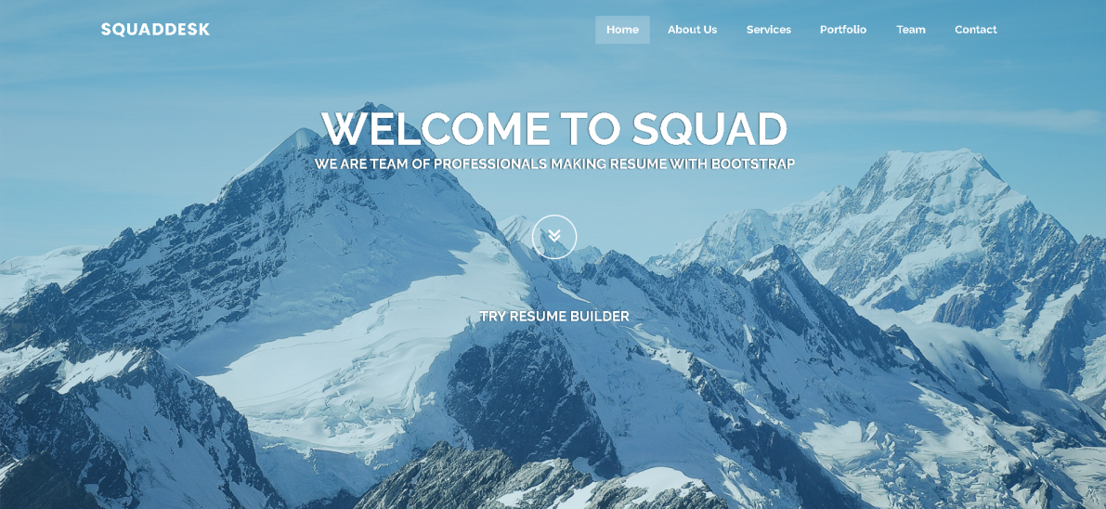

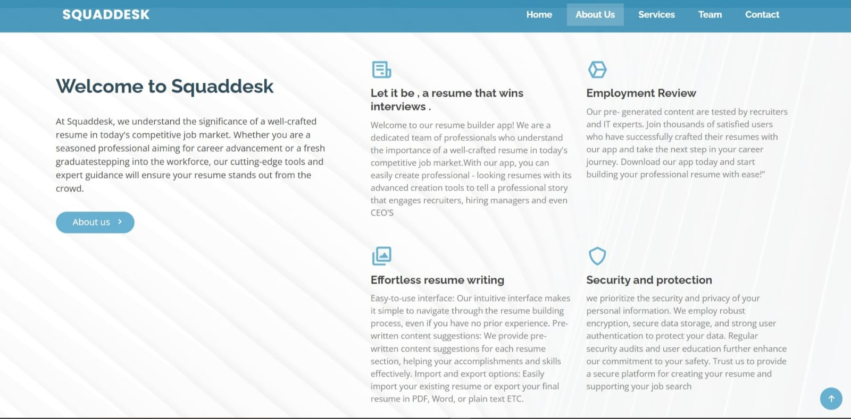

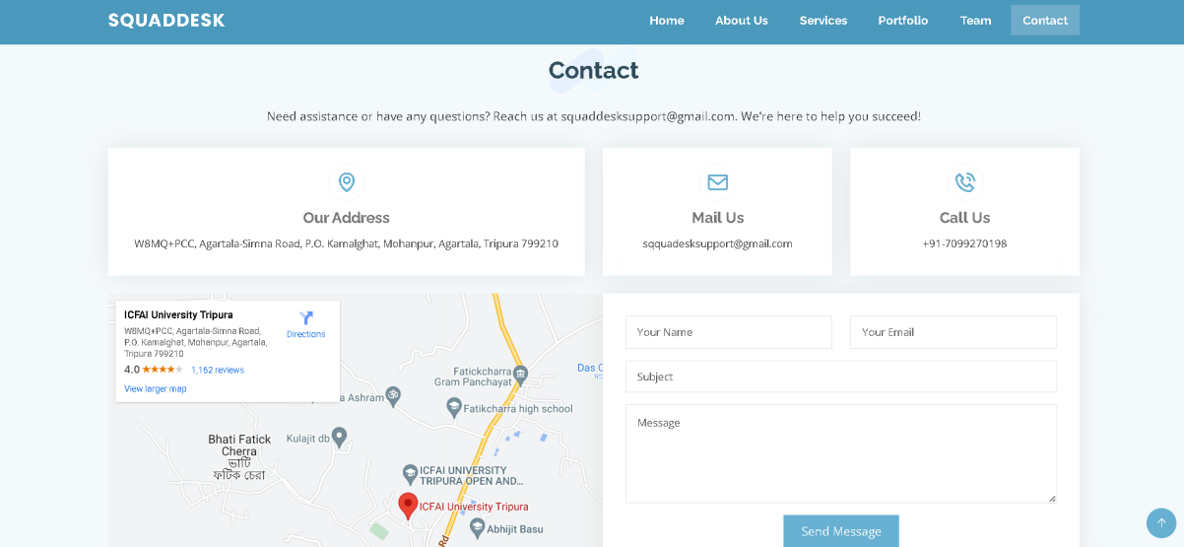

**Chapter 4:Results**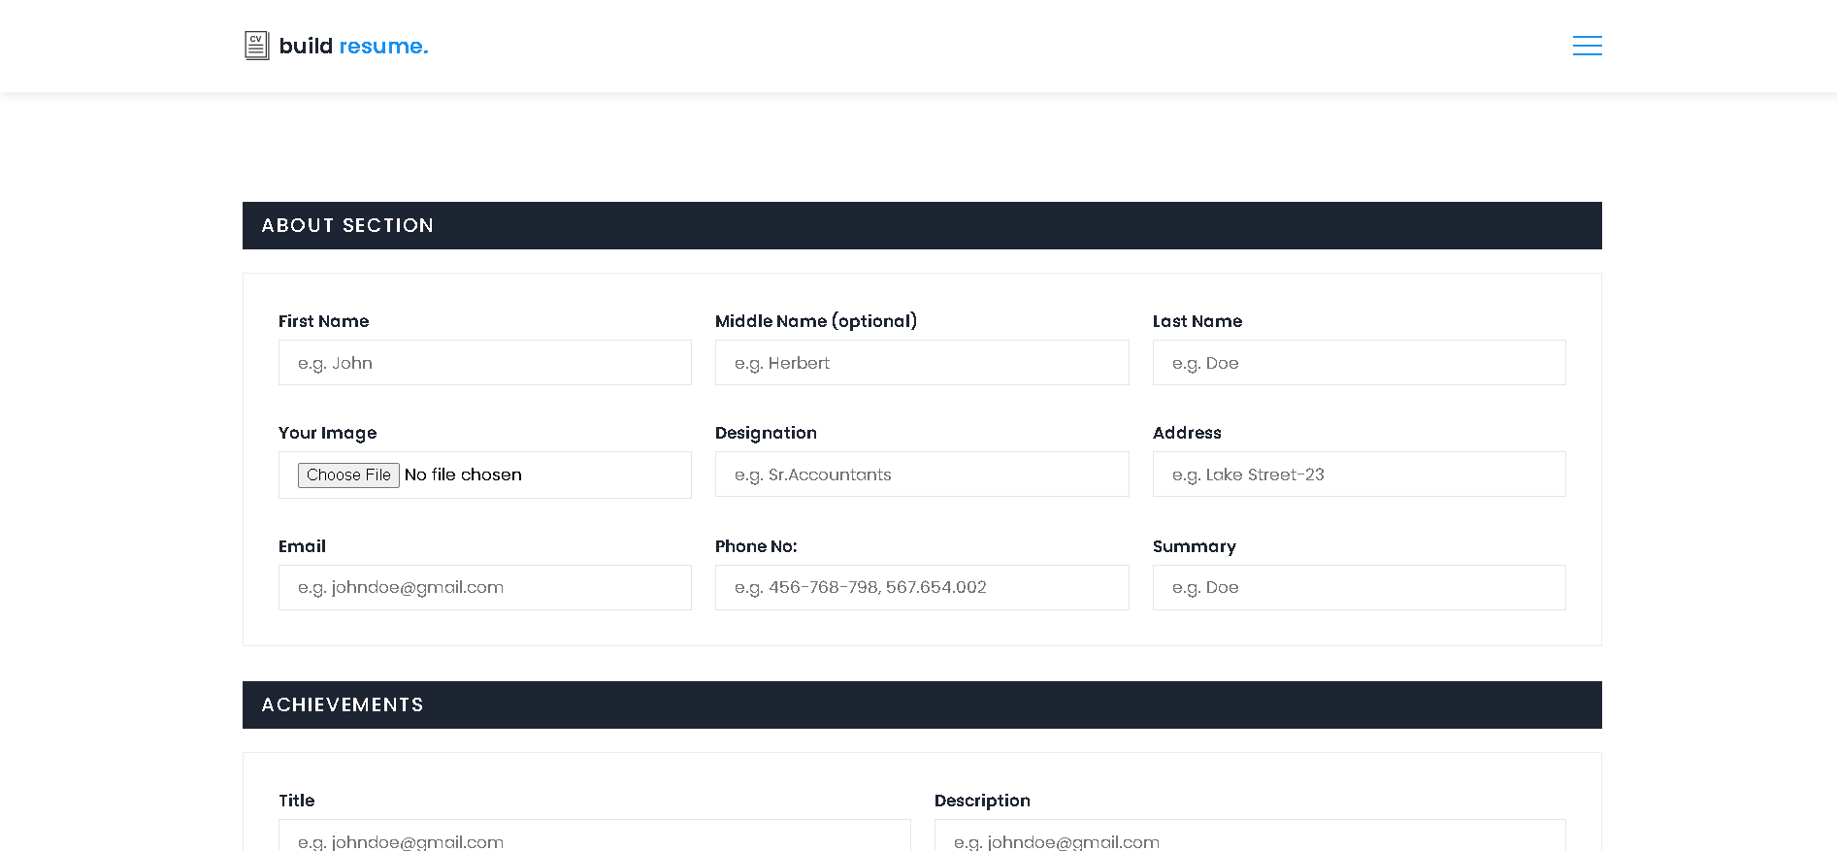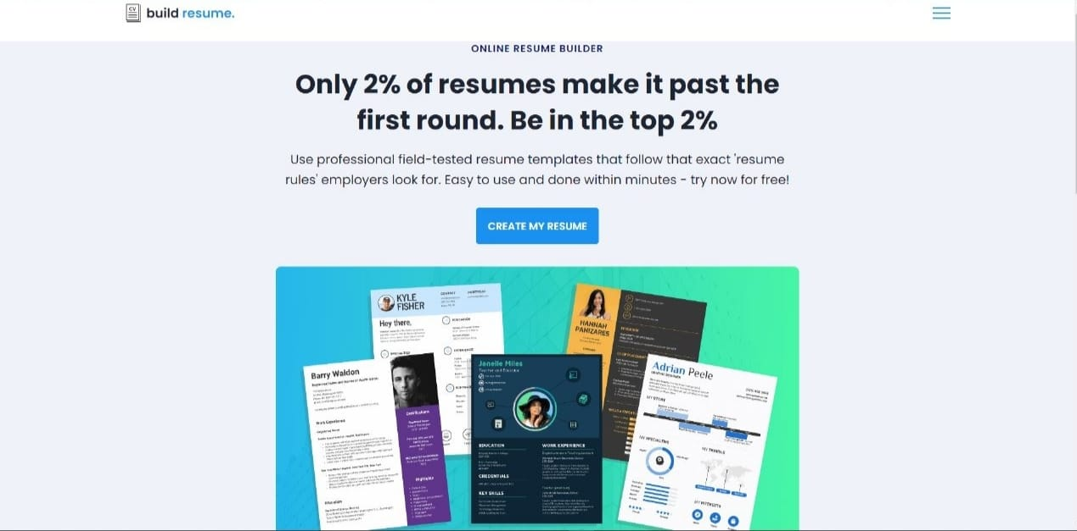

The user-centric approach and innovative features of our platform have yielded remarkable outcomes, making a meaningful impact on our users' careers. Here are some key results and achievements of our resume builder website:

**1.Time Efficiency and Ease of Use:** Our website has streamlined the resume creation process, enabling users to craft a personalized and professional resume in a fraction of the time it would take using traditional methods. The user-friendly interface and intuitive design make it accessible to individuals of all technical backgrounds.

**2. Cross-Platform Accessibility:** Our resume builder is designed to be accessible across different devices, including desktops, laptops, tablets, and smartphones. This flexibility allows users to work on their resumes from anywhere, ensuring their job applications remain up-to-date and consistent.

**3. Customer Satisfaction:** We have received overwhelmingly positive feedback from our users, expressing their satisfaction with the ease of use and the quality of the final product. Many users have shared success stories and expressed gratitude for helping them secure their dream jobs.

In summary, our resume builder website has demonstrated its effectiveness in aiding job seekers in crafting outstanding resumes, leading to increased job application success rates and interview calls.

**Chapter 5:Conclusion**

At **Squaddesk**, we take immense pride in empowering job seekers worldwide with a seamless and efficient resume creation process. With a user-friendly interface and diverse industry-specific templates, we have witnessed thousands of success stories from our users. Our commitment to continuous improvement ensures that we remain at the forefront of the industry, providing cutting-edge tools to boost employability. We are deeply grateful for the trust our users have placed in us, and we will continue to work tirelessly to support their career aspirations.

To all our users, whether starting their journey or seeking career advancements, **Squaddesk** is here to guide you towards success. Your accomplishments drive us forward, and we are dedicated to helping you stand out in the competitive job market. Thank you for being part of our journey, and we look forward to being your partner in achieving your professional goals.

**Chapter 6:References**

1. W3Schools:

Website: W3Schools

URL: <https://www.w3schools.com/>

1. GitHub:

Website: GitHub

URL: <https://github.com/>

1. Frontend Mentor:

Website: Frontend Mentor

URL: <https://www.frontendmentor.io>

1. Bootstrap

Website: Bootstrap

URL: <https://getbootstrap.com/>